

**TITLE OF THE PROJECT**

“**Data Loss Prevention System**”

**NAME OF GUIDE NAME OF TRAINEE**

Mr. Priyakant TanejaSomesh Saxena

**PROJECT REPORT APPROVAL SHEET**

It is certified that the project entitled, “Data Loss Prevention System” was completed by Mr. SOMESH SAXENAunder my guidance during the period w.e.f. 15-JUNE-2017 to 30-JULY-2017 . The same is hereby approved.

**NAME OF THE GUIDE**

Mr. Priyankant Taneja

**DESIGNATION**

**NAME OF WORK CENTER**

SIFY - NOIDA

SECTOR - 132

**ACKNOWLEDGEMENT**

I would like to express my special thanks of gratitude to Mr. Priyakant Taneja who gave me the golden opportunity to do this wonderful project on the topic “ Data Loss Prevention System”, which also helped me in doing a lot of Research and i came to know about so many new things I am really thankful to them.

Thanking you,

Somesh Saxena

**Index**

**Title: Page no.**

Acknowledgement 2.

Index 3.

Introduction 4.

What is DLP and its need? 5.

Various modules of DLP 6.

Data Flow Diagram 7.

Architecture-Email 8.

DLP policies and features 9.

Information & Data required 10.

Reference/Bibliography 12.

**Introduction**

As part of my University, in the 7th semester a industry-training is required. This is the option I chose when the opportunity was given to me to be able to develop a application. I was under the tutelage of Mr. Priyakant Taneja, who offered me as project on Data Loss Prevention System.

I intend to have completed the application once my internship ended, because there was lack of time to

finish my application,and so the graphics are quite neglected, and I would like to add support for the

geolocation in certain situations, but all this will detailed in the section on my application.

**What Is DLP?**

* Data loss prevention (DLP) is a strategy for making sure that end users do not send sensitive or critical information outside the corporate network.

**Why we need DLP?**

* As a bank we have tons of sensitive data like Credit Card Information, personal details collected at the time of account opening, financial information of customers , several financial reports of customers etc.
* Data is undoubtedly the most expensive asset we possess.
* Any data breach can result in loss of revenue, and more importantly, loss of reputation.

**Various Modules of DLP**

**Web DLP**

**Scans all user activities on web and prevent any kind of data loss through web.**

**End-Point DLP**

**Prevents users from leaking out data from their systems through media such as pen drives.**

**E-mail DLP**

**Prevents user from sending sensitive data outside bank domain via e-mail.**

**DATA FLOW DIAGRAM**

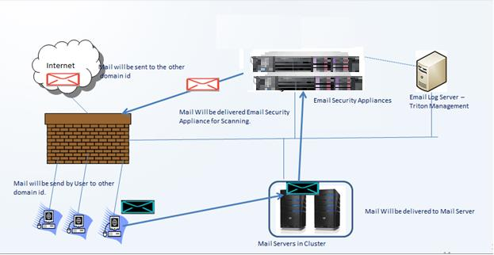

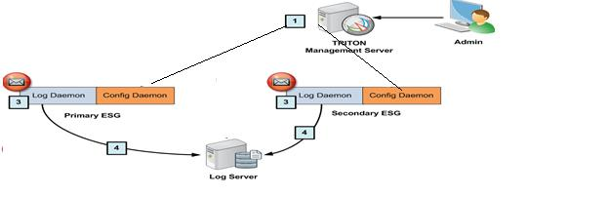

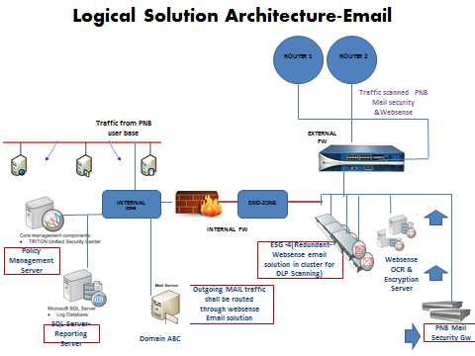

**How DLP Will Function?**

* The DLP appliances sit as a shield between our organization’s mail system and outside domains.
* It scans all mails based on policies defined by the DLP administrator.

**DLP Policies & Features**

* Some policies are predefined, like credit card numbers, bank statements, PAN card details etc.
* Some policies are defined by providing keywords like “Confidential” or “For internal circulation only”.
* Policies can also be defined by providing sample files and thereafter DLP system can fingerprint those files to prevent leak of any other file of same type.

**DLP Policies & Features**

* DLP can even detect phrases and words in scanned documents as it has Optical Character Recognition feature.
* These kind of confidential or sensitive mails can be quarantined and an alert can be sent by the DLP system to the sender or the designated authority in the department or both.

**Information and Data Required**

* As DLP will work based on policies, so to define those policies, we need to know what data is sensitive for your division/department.

* We will require sample files of this data for fingerprinting, e.g. a sample RFP, or sample account details sheet. This sample can be in any format.

**Information and Data Required**

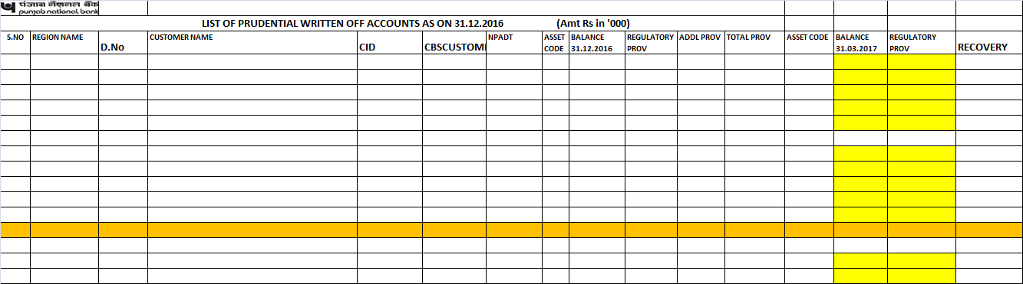

**Information and Data Required**

* Sometimes, for business requirements, it is required to communicate with outside domains like RBI or NPCI and that too with some confidential data. In that case, exception can be provided to such IDs of PNB which will be communicating with outside domains. We require from you a list of IDs which your department/division uses frequently for communication outside PNB.
* Exception to those will be provided so that there is no hindrance in routine business work.

**Bibliography/Reference**

[www.google.com](http://www.google.com)

www.wikipedia.com